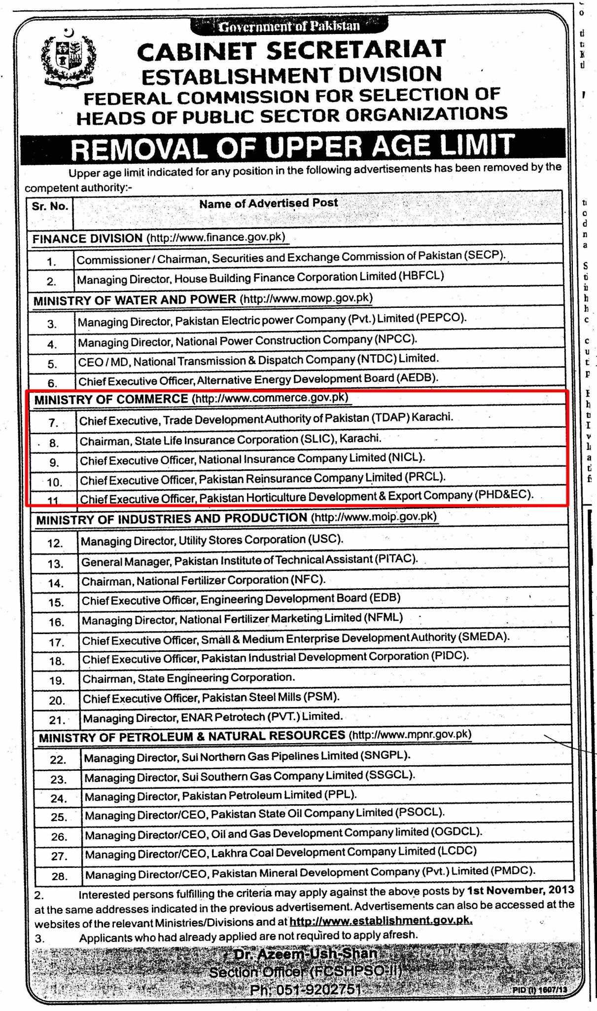
APPLICATION FORM FOR CEO NICL
1. | PERSONAL
a) | Name: (former name if any):
b. | Father’s or Husband Name:
c. | C.N.I.C # (attach copy)
d. | Nationality :
e. | Age:
f. | Contact Details
 | i)Residential Address:
 | ii) Business Address:
 | iii) Tel:
 | iv) Mobile:
 | v) Fax:
 | vi)E-mail
g. | National Tax Number:
h. | Present Occupation:
I. | Qualification(s):
 | i) Academic:
 | S.No. Name of Institution Duration Degree / Diploma % Marks Obtained
ii)Professional:
S.No. | Name of Institution | Duration | Degree / Diploma

2. | WORK EXPERIENCE:  (Positions held since the first professional assignment in descending order )
 | S. No. Organization Duration Job Responsibilities Major Achievements reflecting qualifications / abilities matching to the post Reasons for leaving
2. | Nature of directorship Executive Non-executive  Status of directorship Nominee director  Number of shares subscribed or held:  Nominated by (Name of Shareholder):  Personal Net Worth(Copy of Wealth Statement):
3. | Names of companies, firms and other organizations of which the proposed person is a director, partner, office holder.
4. | Names of persons on the board of the National Insurance Company Limited (NICL) who are related to the applicant. (If any)
5. | What are the current issues and challenges in the Insurance Sector of Pakistan and how can NICL help this sector being a public sector entity. (Write 700 to 800 words)
6. | What makes the applicant the most suitable candidate for the position of CEO, NICL? (Write 400 to 500 words)

I UNDERTAKE THAT I FULLFILL THE CRITERIA OF FIT AND PROPER AS DEFINED IN THE INSURANCE COMPANIES SOUND AND PRUDENT MANAGEMENT REGULATIONS, 2012 AND PUBLIC SECTOR COMPANIES (CORPORATE GOVERNANCE) RULES, 2013.

Signature:

Dated:

Kindly attach the following documents in support of your application.
- Application for the post.
- Detailed CV / Resume containing all the relevant details regarding the academic and professional experience of the applicant.
- Copies of ID Card, National Tax Number (NTN), academic transcripts / degrees and testimonials from former employers attested by a gazetted officer.
- Three latest passport size pictures
- An affidavit to the effect that the candidate is not having dual nationality, duly verified by Magistrate Class-I.

