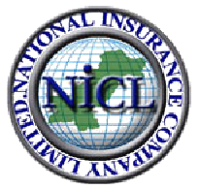National Insurance Company Limited
(Owned By the Government of Pakistan)

PRELIMINARY INFORMATION SHEET
Form TIC-01
TRAVEL INSURANCE (INCLUDING TERRORISM COVER) FOR VISITING FOREIGN BUYERS OR THEIR FOREIGN AGENTS

S. No. | Name of Applicant | Citizenship | Date of entry in Pakistan | Duration of Stay in Pakistan | Chose Coverage Plan | Contact Information i.e. Phone No; Email or Fax | Nominee Address and Contact Information

Please fill in all the field and either fax it at 00 92 51 9216424 or email at nazim.latif@nicl.com.pk and khurram.irshad@nicl.com.pk

